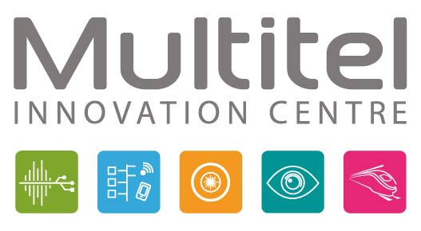

**Job Offer: Mechatronics Engineer – Applied Photonics Department**  
**Location:** Multitel, Research Center, Mons, Belgium  
**Availability:** Immediate

**About Multitel:**  
Multitel is an innovative research center specializing in several technological fields, including applied photonics. Recognized internationally as a hub of expertise, Multitel develops and integrates emerging technologies into the industrial fabric of Wallonia. We work on cutting-edge projects such as fiber laser development, biophotonics, and laser processes in collaboration with partners across Europe.

We are looking for a Mechatronics Engineer to join our applied photonics department and contribute to advanced research projects.

**Main Responsibilities:**  
• Design and develop mechatronic systems for photonics applications (fiber lasers, biophotonics, laser processes).

• Propose technical solutions justified through models, calculations, and tests aimed at reducing costs, improving performance, and enhancing durability.

• Collaborate on R&D projects in partnership with organizations from several European countries.

**Required Skills:**

**Electronics Skills:**  
• Expertise in analog electronics, with a specialization in Analog Signal Processing (ASP), particularly in the transimpedance amplification of very low currents (pA) and the integration of high-frequency signals (~100 MHz).  
• Design and development of electronic circuits for complex systems.  
• Programming in C/C++, VHDL, and Python is preferred for electronic system integration.

**Mechanical Skills:**  
• Proficiency in CAD software like SolidWorks for the design and manufacturing of parts (CNC, sheet metal, etc.).  
• Knowledge of mechanical simulation and behavior for complex parts.  
• Management of thermal aspects related to mechatronic systems.  
• Use of tools such as 3D printers for rapid prototyping and concept validation.

**Additional Skills:**  
• Experience in optoelectronics, optics, or applied photonics is a plus.  
• English proficiency at B2+ level, essential for interacting with our European partners.  
• 2 to 3 years of experience, but motivated beginners will also be considered.

**Benefits:**  
• Work on collaborative research projects with European partners in the field of photonics.  
• Access to cutting-edge technologies for development and prototyping.  
• Opportunities for growth and development in an innovative research environment.  
• Option for remote work one day per week.  
• Attractive salary package including numerous extra-legal benefits.

**Application Process:**  
Send your CV and cover letter to hernandez@multitel.be