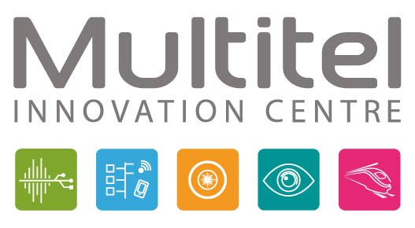

Recognized as an international hub of expertise, Multitel develops and integrates emerging technologies into the industrial fabric of Wallonia. These technologies are focused on five areas of activity: Networks and Telecoms, Applied Photonics, Signal & Embedded Systems, Computer Vision, and Railway Certification. Multitel supports companies in their technological innovation projects, from exploratory and feasibility phases to the development of prototypes and processes.

**Industrial Engineer, "Business Developer"**

For its Applied Photonics department, Multitel is recruiting engineers with a background in optics for new projects, particularly in the field of non-destructive testing of materials. You will contribute to the development of new solutions for 3D material analysis. As part of a collaborative project, you will perform tests on various parts produced by additive technologies. The measurement tools (primarily based on THz technology) will need to be adapted for 3D parts (programming/automation). Furthermore, in a multi-actor environment (within a multidisciplinary center bringing together several stakeholders: centers, companies, etc.), you will interact with numerous regional actors. Strong interpersonal skills will be essential to successfully carry out the responsibilities of this role (establishing new contacts, discovering new collaboration opportunities, proposing ideas, etc.).

**Your Skills/Qualities:**  
• Industrial Engineer  
• Open-minded (willing to learn new technologies)  
• Strong interpersonal skills (ability to communicate within an ecosystem to seize opportunities)  
• Autonomy

**Additional Skills:**  
• Programming/Automation: Python, C, C++... Interfacing, synchronization, data acquisition.  
• Ability to write scientific and technical documents and present results.  
• A first experience in activities related to photonics/lasers or even terahertz would be a plus.  
• 2 to 3 years of experience, but motivated beginners are also accepted.  
• A valid driver’s license (B)

You will join a team of about fifteen people working in various fields of photonics, offering the opportunity to contribute to numerous multisectoral research projects. Most of your time will be spent at the A6K multidisciplinary center in Charleroi, which will provide you with significant autonomy in your work.

**Contact:** hernandez@multitel.be  
**Multitel, Parc Initialis,** 2, Rue Pierre et Marie Curie, 7000 Mons, Belgium