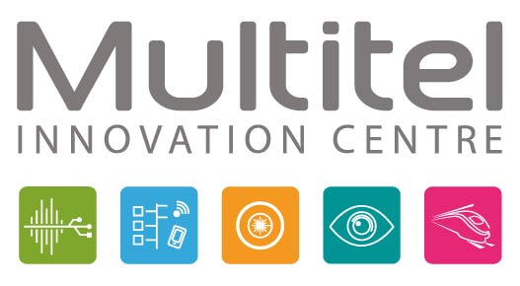

Recognized as an international hub of expertise, Multitel develops and integrates emerging technologies into the industrial fabric of Wallonia. These technologies focus on five areas of activity: Networks and Telecoms, Applied Photonics, Signal & Embedded Systems, Computer Vision, and Railway Certification. Multitel supports companies in their technological innovation projects, from exploratory and feasibility phases to the development of prototypes and processes.

**Laser Development Engineers**

For its Applied Photonics department, Multitel is recruiting engineers with a background in optics for new projects, particularly in the field of fiber laser sources. You will contribute to the development of new laser sources operating in pulsed mode. As part of a European collaboration, you will work on the development of new tunable pulsed sources for imaging applications.

**Your Skills:**  
• Photonics: Lasers, non-linear effects  
• Laboratory: Good knowledge of using classic equipment: optical radiometer, spectrum analyzer, fiber welders, etc.  
• Programming: Python, C, C++...  
• Ability to write scientific and technical documents and present results.  
• A first experience in activities related to photonics/lasers.  
• 2 to 3 years of experience, but motivated beginners are also accepted.  
• A valid driver’s license (B)

You will join a team of about fifteen people working in different areas of photonics: lasers, micro-machining, terahertz spectroscopy, biophotonics, and sensors, giving you the opportunity to contribute to numerous multisectoral research projects.

**Contact:** [hernandez@multitel.be](mailto:hernandez@multitel.be)  
**Multitel, Parc Initialis**  
2, Rue Pierre et Marie Curie  
7000 Mons, Belgium